Step 1: - Create a microservice using python

1. Create a new empty folder in local disk D.
2. Go to the vs code and create a virtual environment. using terminal commands.
3. Python -m venv D:\microservices\venv and using ctrl+shift+p select python: select interpreter find path to python.exe and close the terminal and open new terminal activate the virtual environment in vscode.

Step 2: Install the FastAPI and webserver uvicron

1. Pip install fastapi

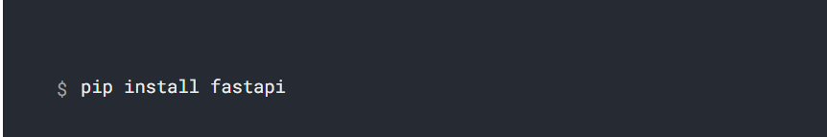

1. Pip install uvicorn

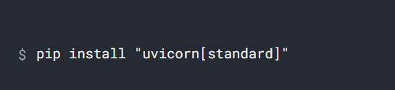

1. Create App directory and main.py file

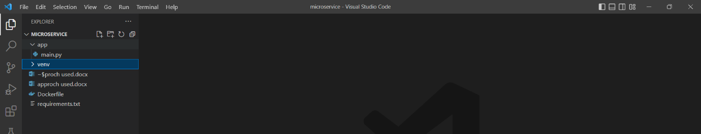

1. Copy the code in fastapi website and paste in main.py

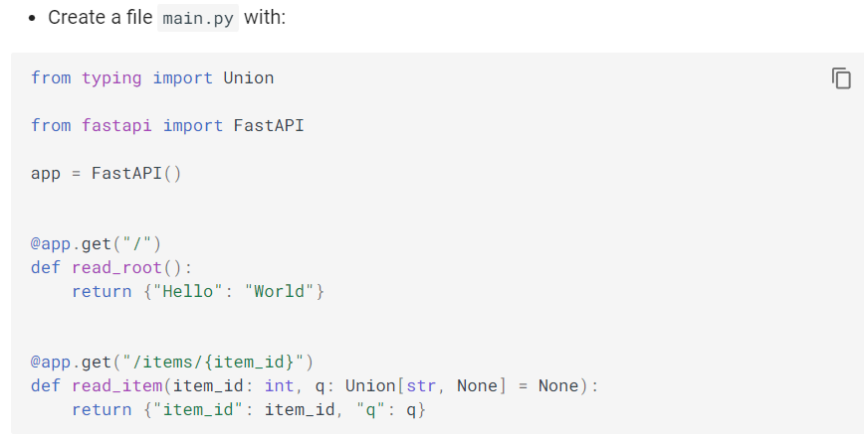

1. Import the uvicorn and webserver in mai.py file
2. Go to folder cd app and run python main.py file
3. Server will run and port



Step 3: Now we want to Dockerize.

1. First thing we have to save requirements dependencies using terminal command

Pip Freeze > requirements.txt

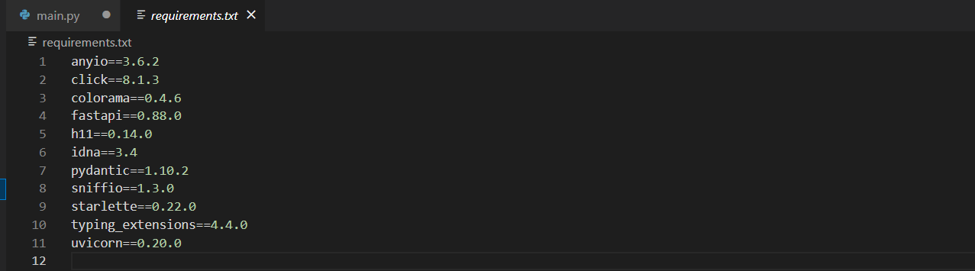

1. Create a docker file.

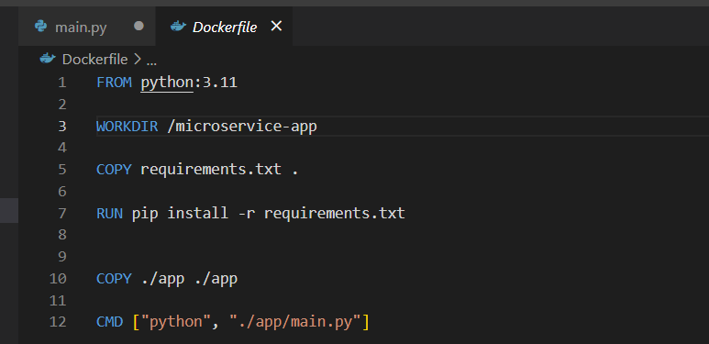

1. Run command docker build -t python-fastapi .
2. Docker run python-fastapi b ut it will not run

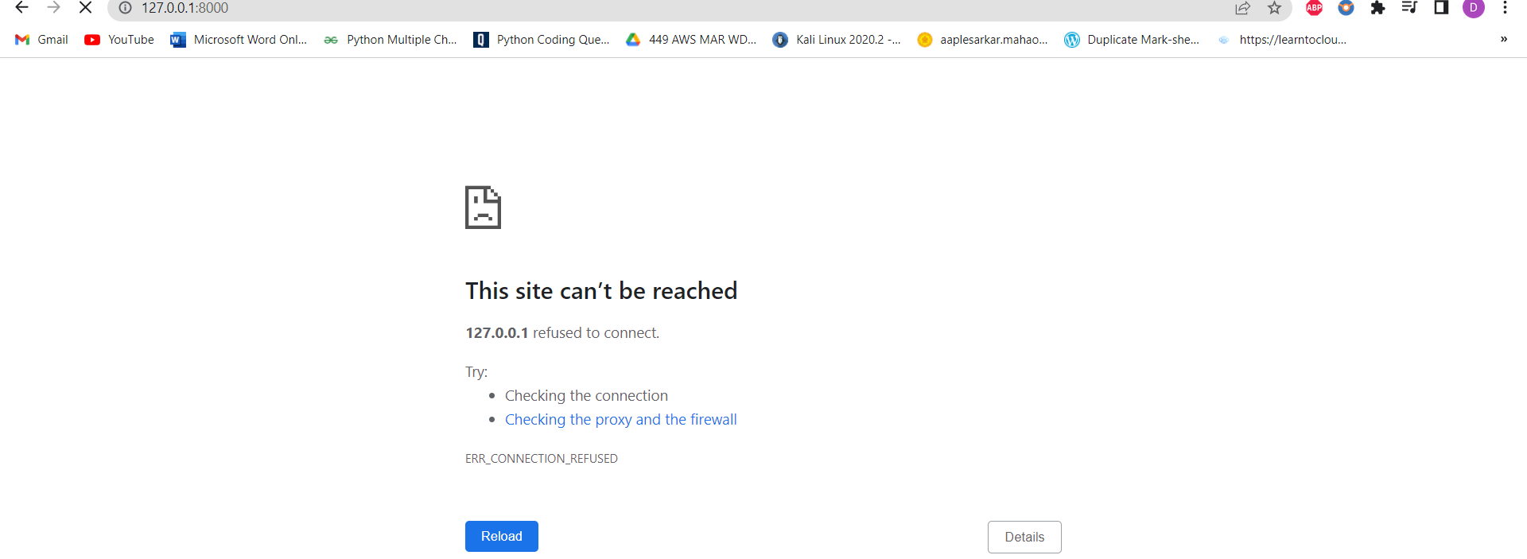

1. We have given a port 8000 and host 0.0.0.0

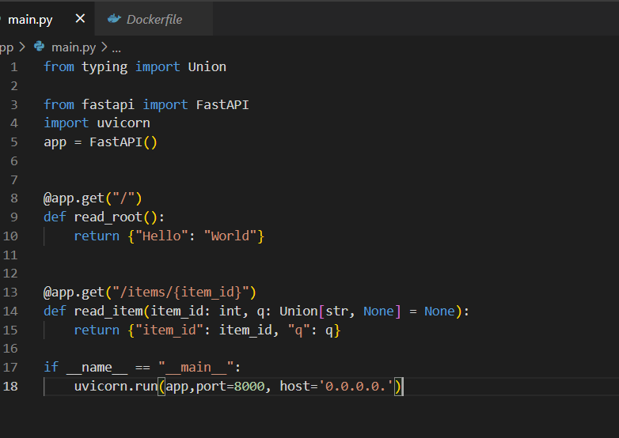

1. Build the image docker build -t python-fastapi .
2. Run the -p 8000:8000 python-fastapi

